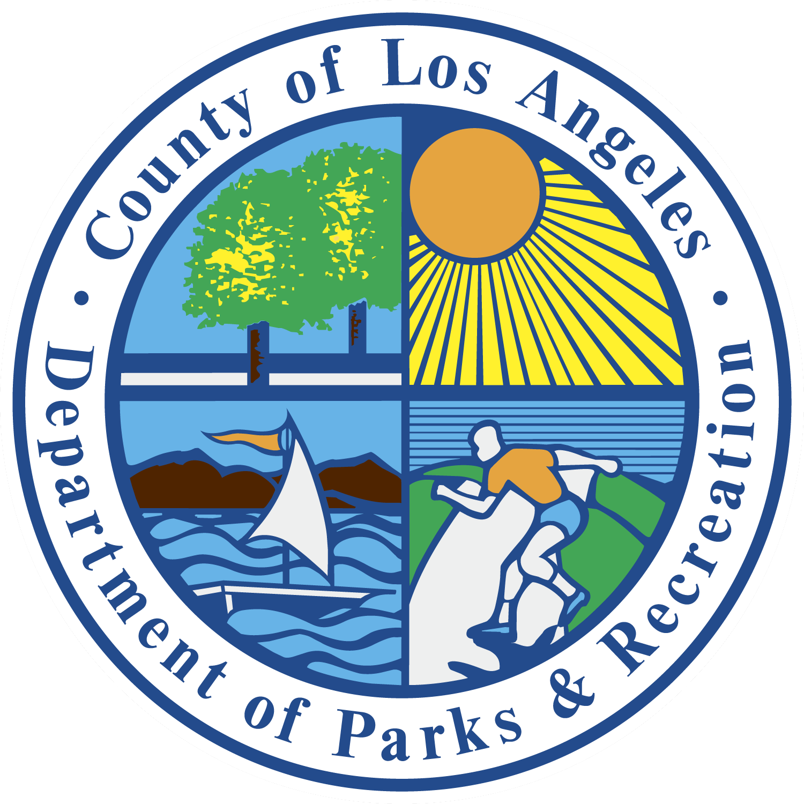

CONTRACT CLASS PROGRAM COORDINATORS

Contract Class Program Coordinators are assigned by geographical areas of Los Angeles County. Please contact the coordinator of the area in which you wish to teach a class regarding the application process.

North Agency: Antelope Valley District, Santa Clarita District and Foothill District
- Samuel Estrada: SEstrada@parks.lacounty.gov; (626) 798-6335
- William Champion: WChampion@parks.lacounty.gov; (661) 940-7701

East Agency: East LA District, Heights District and San Gabriel Valley District
- Brian Ceballos: BCeballos@parks.lacounty.gov; (626) 333-3250
- Traci Anthony: TAnthony@parks.lacounty.gov; (626) 333-1369

South Agency: Southeast District, the Southwest District and the Central West District
- Susan Curry: SCurry@parks.lacounty.gov; (310) 908-3277
- John Baker: JBaker@parks.lacounty.gov; (562) 698-2000
- Alejandro Noriega: ANoriega@parks.lacounty.gov; (310) 654-3709

Regional Agency: Regional facilities and Nature Centers across LA County:
- Marlene Yang: MLang@parks.lacounty.gov; (310) 519-6115
- Tatiana Gardener: Tgardener@parks.lacounty.gov; (310) 202-3002

For general inquiries, please email ContractClasses@parks.lacounty.gov.

